**SLMet Sierra Leone Dry Seasonal Outlook (January to April 2025)**

**1. Introduction**

This document provides a detailed dry seasonal outlook for Sierra Leone, covering January to April 2025. It includes temperature trends, dust forecasts, potential risks, and actionable recommendations. The projections are based on SLMet’s historical data, meteorological models, and global climate patterns such as the El Niño-Southern Oscillation (ENSO).

The 2025 dry season projection poses significant challenges due to above-average temperatures and associated risks. However, coordinated efforts among government, private sector, and communities will be essential to mitigate the impacts and ensure resilience. Thus, SLMet will continue to provide timely updates and guidance to support national planning.

**2. General Overview of January, February, March and April 2025 Temperature Predictions**

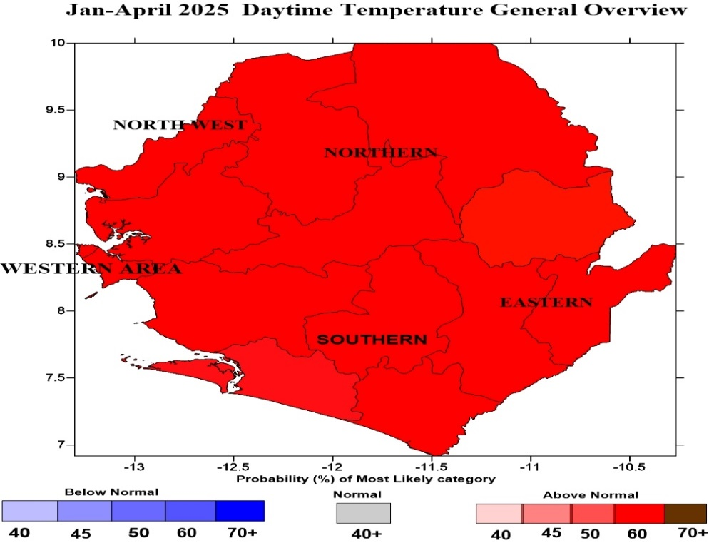

Figure 1: Jan - Apr 2025 Temperature prediction

The 2025 dry season is expected to be hotter than average, influenced by ongoing El Niño conditions as depicted in figure 1 above. The daytime temperatures are predicted to range between **28°C and 40°C** across most regions, with the northern and northeastern parts experiencing the highest extremes. However, the nighttime temperatures will remain relatively warm, averaging **22°C to 26°C**.

**3. Regional Temperature Highlights**

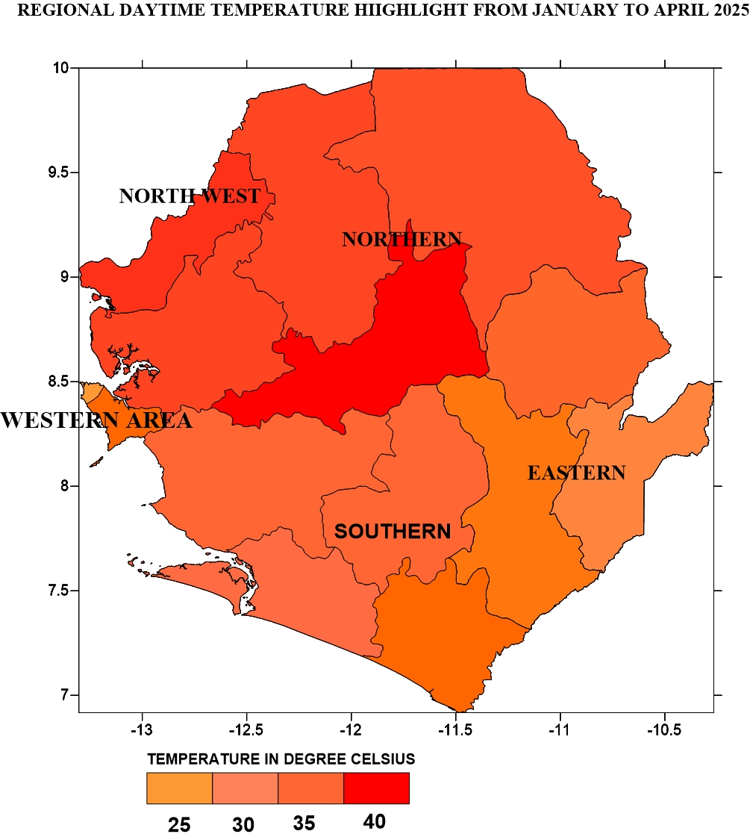

Figure 2: Jan-Apr 2025 Regional Daytime Temperature prediction

From figure 2 above:

* **Western Area (Freetown and Coastal Areas):** Daytime temperature around 30°C to 34°C; humidity levels remain elevated, exacerbating heat stress.
* **Northern Region:** Daytime temperature between 35°C and 39°C, with significant nighttime cooling challenges.
* **Eastern Region:** Daytime temperature ranging from 28°C to 33°C, with potential for isolated heat waves.
* **Southern Region:** Daytime temperature will account moderate temperatures from 29°C to 34°C

**4. Dust Prediction**

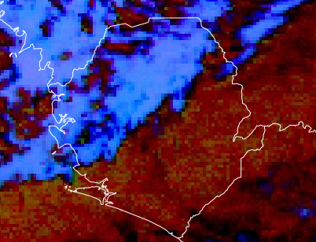

Figure 3: Predicted Jan-April 2025 Dust

* The Harmattan winds, originating from the Sahara Desert, will dominate from **mid-January to March**, bringing dry, dusty conditions across the country.
* **Dust Concentration:** High concentrations of particulate matter (PM10 and PM2.5) are expected, significantly reducing visibility to **1-3 kilometers** during peak events.
* **Air Quality Impact:** Moderate to severe air quality deterioration, with AQI (Air Quality Index) likely to reach "Unhealthy" levels in February.

**5. Regional Impact**

* **Northern Regions:** Higher dust intensity due to proximity to Sahel zones.
* **Coastal Regions:** Slightly lower dust density but still impactful, especially during strong Harmattan surges.

**6. Potential Risks**

**6.1. Agriculture and Food Security**

* **Prolonged Dry Spells:** Reduced water availability may affect crop irrigation and livestock health.
* **Pest Infestations:** Increased temperatures may exacerbate outbreaks of pests, impacting crop yields.

**6.2. Health Impacts**

* **Heat-Related Illnesses:** Higher temperatures increase the risk of heat exhaustion, dehydration, and heatstroke, particularly among vulnerable groups such as children and the elderly.
* **Waterborne Diseases:** Reduced water quality and quantity could lead to outbreaks of cholera and typhoid.

**6.3. Water Resources**

* **Decreased Availability:** River levels and groundwater reserves are expected to decline, impacting domestic, agricultural, and industrial water use.
* **Urban Areas:** Increased demand may lead to water rationing in Freetown and other major cities.

**6.4. Energy Sector**

* **Hydropower Challenges:** Reduced river flow could limit hydropower generation, potentially leading to energy shortages.
* **Increased Energy Demand:** Higher temperatures may drive demand for cooling, straining existing power infrastructure.

**6.5. Wildfire Risks**

* **Bushfires:** Dry vegetation increases the risk of wildfires, particularly in northern region.

**7. Recommendations**

**7.1. For Government and Policymakers**

* **Water Resource Management:** Implement rationing and prioritize water supply for critical uses, including agriculture and public health.
* **Heat Action Plans:** Develop localized heat action plans, including early warning systems for heatwaves.
* **Agricultural Support:** Provide drought-resistant seeds, pest management resources, and financial aid to farmers.

**7.2. For Communities and Households**

* **Water Conservation:** Encourage efficient water use.
* **Health Precautions:** Increase awareness about hydration and heat illness prevention.
* **Fire Safety:** Educate communities on preventing and responding to fires.

**7.3. For Key Sectors**

* **Health Sector:** Ensure medical facilities are stocked with supplies to treat heat-related illnesses.
* **Energy Sector:** Promote renewable energy solutions like solar to reduce dependency on hydropower.
* **Agriculture:** Encourage early planting and the use of efficient irrigation techniques.

**Prepared by:**  
Sierra Leone Meteorological Agency (SLMet)  
January 2025